PHYS 201 Help Session on Rotational Dynamics 11/18/19, 2-3 pm, Sims 207.
1. Before coming, please watch the attached video and be ready to talk about what you learned from the video. https://www.youtube.com/watch?v=jb93dUFCUBE
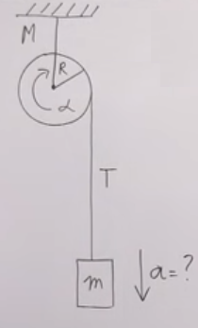
3. Three forces are applied to a solid cylinder of mass 15 kg (see the drawing). The magnitudes of the forces are F₁ = 16 N, F₂ = 25 N, and F₃ = 17 N. The radial distances are R₂ = 0.25 m and R₃ = 0.12 m. The forces F₂ and F₃ are perpendicular to the radial lines labeled R₂ and R₃.
a. Find the magnitude of the angular acceleration of the cylinder about the axis of rotation.
b. If the cylinder is at rest initially, how long will it take the cylinder to rotate 3 revolutions?
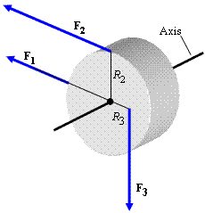

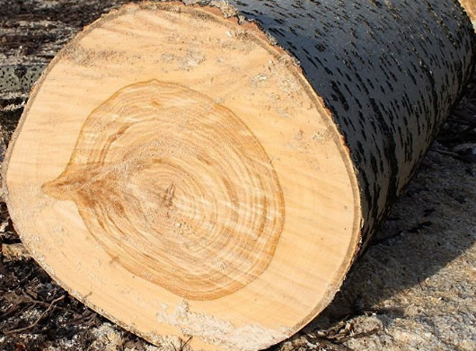
4. A tree stump (cylindrical in shape, mass of 170 kg and diameter of 50 cm) needs to be moved by rotating it. Assume that the force is exerted parallel to the cylindrical surface.
a. What force is needed to give an initial angular acceleration of 15 rad/s²?
b. If a human can exert a maximum force of 80 N, how many people are necessary to give the above initial angular acceleration?

$$I= \frac{1}{12}ML^{2}$$ | $$I= \frac{1}{3}ML^{2}$$

5. A rod of mass 65 g and length 80 cm with a mass of 25 g attached at one end and hinged at the other end is shown below. It is held at rest vertically and released and falls as shown.
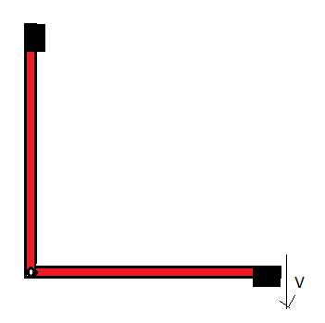
a. Determine the moment of inertia of the mass and rod about the hinge as the axis.
b. Using conservation of energy, find the velocity of the mass when the rod is horizontal and falling?

